**While migrating, you are asked to perform the following**

**tasks:**

1. Create a DynamoDB table with partition key as ID.

2. Add 5 items to the DynamoDB table.

3. Take backup and delete the table.

Search DynamoDb and click on create table🡪

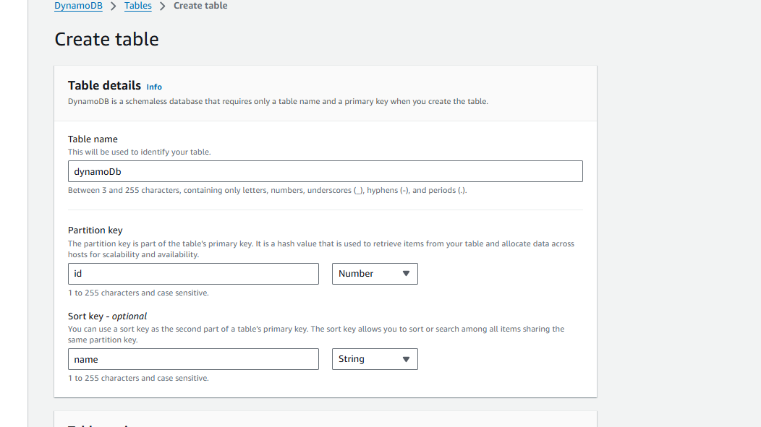

We have select id as partition key and name as sort key.

We have taken other properties as default.

Create table.

We can see our new table in dashboard.

Now to insert the data in table just go in actions and select create item🡪

Like this create 5 items.

Now we have to take backup of this🡪

Go into backups🡪 create backups

In customize setting select backup now.

Click on create backup.

We can see our backup getting created in backup jobs.

Now we can delete our table.

